2022 Summer Dance June 27 to August 4
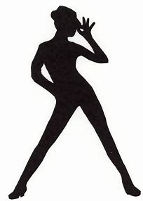 | Monday | Tuesday | Wednesday | Thursday | Friday | Saturday
Studio A | NEW!  5-5:45 Jazzerina  Int/Adv Ballet  5:45-6:30 | 4:45-5:30  Creative Movement for Tots  5:30-6  Intro Ballet/ Tap  Mrs. Ebonee | STUDIO IS  CLOSED BUT OPEN FOR PRIVATE LESSONS! | 5-6  Int/Adv Ballet  Mrs. Ebonee  6-6:45  Mid & Upper  Hip hop | STUDIO IS  CLOSED BUT OPEN FOR PRIVATE LESSONS!  CALL 302.566.6551 | NEW CLASS!  10-11am  Dance in heels  This class is for teens & up.
 | *Ladies Strip Fitness  6:30-7:15 | 6-6:45 Beginner  Hip-hop |  | Contemporary  Ballet  6:45-7:15  Mrs. Ebonee |  | * Ladies Strip  Fitness  9:30am
Studio B |  | 6:45- 7:30  Beginner Ballet  1-3

Schedules are subject to change without any notice of any kind.

